Inventory Management System

Core Resources:

1. Warehouse: has product:
2. Product: stored in a warehouse
3. Order: has multiple products
4. Customer: has multiple orders

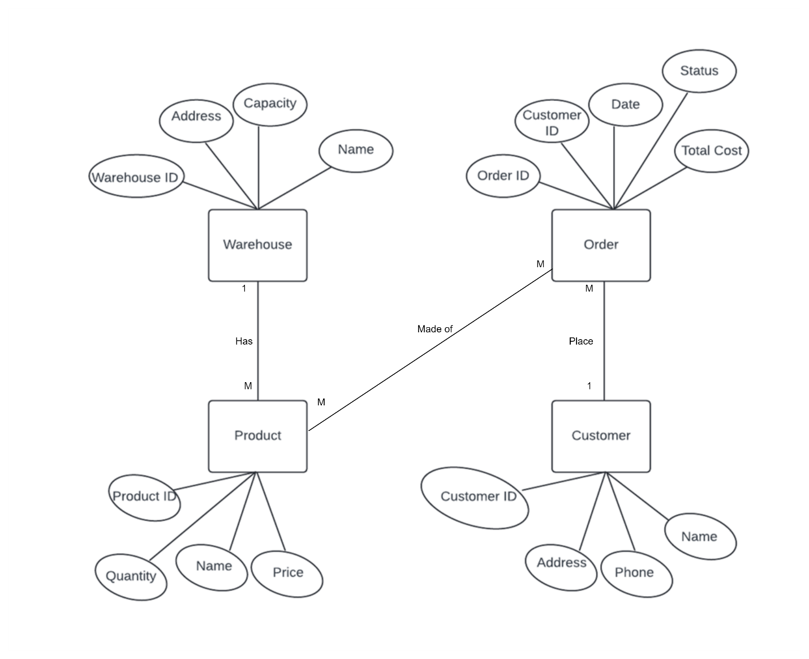

|  |  |  |  |  |  |
| --- | --- | --- | --- | --- | --- |
| Collection Resource (/Customers) | | | | | |
| HTTP request (method URI) | Operation | Description | HTTP status codes | Request sample | Response sample |
| POST/Customer | Create a customer | Using this method we create a new customer | 201 (created) | Localhost:8080/ Inventory_Management  _System /customers | Customer:{  Id:1  Message:”Customer Created Successfully”  } |
| GET/Customers | Read all customers | Using this method we get every customer in the database | 200 (OK) | Localhost:8080/ Inventory_Management  _System /customers | Customer:{  Id: 1  Name:hadi  Address:{  City:Ramallah  Street:2  }  }  Customer:{  Id: 1  Name:hadi  Phone:0599299434  Address:{  City:Ramallah  Street:2  }  }… |
| PUT/Customer/{id} | Update a customer | Using this method we update customer info using his ID | 200 (OK)  404 (Not Found) | Localhost:8080/ Inventory_Management  _System /customers/1 | Customer:{  Id:1  Message:”Customer Updated Successfully”  } |
| PATCH/Customer/{id} | Partially update a customer | Here we make a small update for the customer info | 200 (OK)  404 (Not Found) | Localhost:8080/ Inventory_Management  _System /customers/1 | Customer:{  Id:1  Message:”Customer Modified Successfully”  } |
| DELETE/Customer/{id} | Delete a customer | We delete an existing customer using his ID | 200 (OK)  404 (Not Found) | Localhost:8080/ Inventory_Management  _System /customers/1 | Customer:{  Id:1  Message:”Customer Deleted Successfully”  } |
| GET/Customers/ {id} | Read a customer | Here we get a customer info using his ID | 200 (OK)  404 (Not Found) | Localhost:8080/ Inventory_Management  _System /customers/1 | Customer:{  Id: 1  Name:hadi  Phone:0599299434  Address:{  City:Ramallah  Street:2  }  } |

|  |  |  |  |  |  |
| --- | --- | --- | --- | --- | --- |
| Collection Resource (/Warehouse) | | | | | |
| HTTP request (method URI) | Operation | Description | HTTP status codes | Request sample | Response sample |
| POST/ Warehouse | Create a Warehouse | Using this method we create a new Warehouse | 201 (created) | Localhost:8080/ Inventory_Management  _System / Warehouse | Warehouse:{  Id:1  Message:” Warehouse Created Successfully”  } |
| GET/ Warehouse | Read all Warehouses | Using this method we get every Warehouse in the database | 200 (OK) | Localhost:8080/ Inventory_Management  _System /customers | Warehouse:{  Id: 1  Name:storage1  Phone:0599299434  Address:{  City:Ramallah  Street:2  }  Capacity:100  }  Warehouse:{  Id: 2  Name:storage2  Phone:0599299434  Address:{  City:Ramallah  Street:2  }  Capacity:100  }… |
| PUT/ Warehouse /{id} | Update a Warehouse | Using this method we update Warehouse info using his ID | 200 (OK)  404 (Not Found) | Localhost:8080/ Inventory_Management  _System / Warehouse /1 | Warehouse:{  Id:1  Message:”Warehouse Updated Successfully”  } |
| PATCH/ Warehouse /{id} | Partially update a Warehouse | Here we make a small update for the Warehouse info | 200 (OK)  404 (Not Found) | Localhost:8080/ Inventory_Management  _System / Warehouse /1 | Customer:{  Id:1  Message:”Warehouse Modified Successfully”  } |
| DELETE/ Warehouse /{id} | Delete a Warehouse | We delete an existing Warehouse using his ID | 200 (OK)  404 (Not Found) | Localhost:8080/ Inventory_Management  _System / Warehouse /1 | Customer:{  Id:1  Message:”Warehouse Deleted Successfully”  } |
| GET/ Warehouse / {id} | Read a Warehouse | Here we get a Warehouse info using his ID | 200 (OK)  404 (Not Found) | Localhost:8080/ Inventory_Management  _System / Warehouse /1 | Warehouse:{  Id: 1  Name:storage1  Phone:0599299434  Address:{  City:Ramallah  Street:2  }  Capacity:100  } |

|  |  |  |  |  |  |
| --- | --- | --- | --- | --- | --- |
| Collection Resource (/Order) | | | | | |
| HTTP request (method URI) | Operation | Description | HTTP status codes | Request sample | Response sample |
| POST/ Order | Create a Order | Using this method we create a new Order | 201 (created) | Localhost:8080/ Inventory_Management  _System / Orders | Customer:{  Id:1  Message:” Order Created Successfully”  } |
| GET/ Orders | Read all Orders | Using this method we get every Order in the database | 200 (OK) | Localhost:8080/ Inventory_Management  _System / Order | Order:{  Id: 1  Customer ID:20  Date:20/4/2024  Status: delivered  Total cost: 100$  }  Order:{  Id: 2  Customer ID:20  Date:21/4/2024  Status: delivered  Total cost: 200$  }  }… |
| PUT/ Order /{id} | Update a Order | Using this method we update Order info using his ID | 200 (OK)  404 (Not Found) | Localhost:8080/ Inventory_Management  _System / Orders/1 | Customer:{  Id:1  Message:” Order Updated Successfully”  } |
| PATCH/ Order /{id} | Partially update a Order | Here we make a small update for the Order info | 200 (OK)  404 (Not Found) | Localhost:8080/ Inventory_Management  _System / Orders/1 | Customer:{  Id:1  Message:” Order Modified Successfully”  } |
| DELETE/ Order /{id} | Delete a Order | We delete an existing Order using his ID | 200 (OK)  404 (Not Found) | Localhost:8080/ Inventory_Management  _System / Orders/1 | Customer:{  Id:1  Message:” Order Deleted Successfully”  } |
| GET/ Order / {id} | Read a Order | Here we get a Order info using his ID | 200 (OK)  404 (Not Found) | Localhost:8080/ Inventory_Management  _System / Orders/1 | Order:{  Id: 1  Customer ID:20  Date:20/4/2024  Status: delivered  Total cost: 100$  } |

|  |  |  |  |  |  |
| --- | --- | --- | --- | --- | --- |
| Collection Resource (/Products) | | | | | |
| HTTP request (method URI) | Operation | Description | HTTP status codes | Request sample | Response sample |
| POST/ Products | Create a Products | Using this method we create a new Products | 201 (created) | Localhost:8080/ Inventory_Management  _System / Products | Products:{  Id:1  Message:” Products Created Successfully”  } |
| GET/ Products | Read all Products | Using this method we get every Products in the database | 200 (OK) | Localhost:8080/ Inventory_Management  _System / Products | Products:{  Id: 1  Name:choclate  Quantity:20  Price:2$  }  Products:{  Id: 2  Name:chips  Quantity:40  Price:3$  }… |
| PUT/ Product/{id} | Update a Products | Using this method we update Products info using his ID | 200 (OK)  404 (Not Found) | Localhost:8080/ Inventory_Management  _System / Products /1 | Customer:{  Id:1  Message:” Products Updated Successfully”  } |
| PATCH/ Products /{id} | Partially update a Products | Here we make a small update for the Products info | 200 (OK)  404 (Not Found) | Localhost:8080/ Inventory_Management  _System / Products /1 | Customer:{  Id:1  Message:” Products Modified Successfully”  } |
| DELETE/ Products /{id} | Delete a Products | We delete an existing Products using his ID | 200 (OK)  404 (Not Found) | Localhost:8080/ Inventory_Management  _System / Products /1 | Customer:{  Id:1  Message:” Products Deleted Successfully”  } |
| GET/ Products / {id} | Read a Products | Here we get a Products info using his ID | 200 (OK)  404 (Not Found) | Localhost:8080/ Inventory_Management  _System / Products /1 | Products:{  Id: 1  Name: choclate  Quantity:20  Price:2$  } |